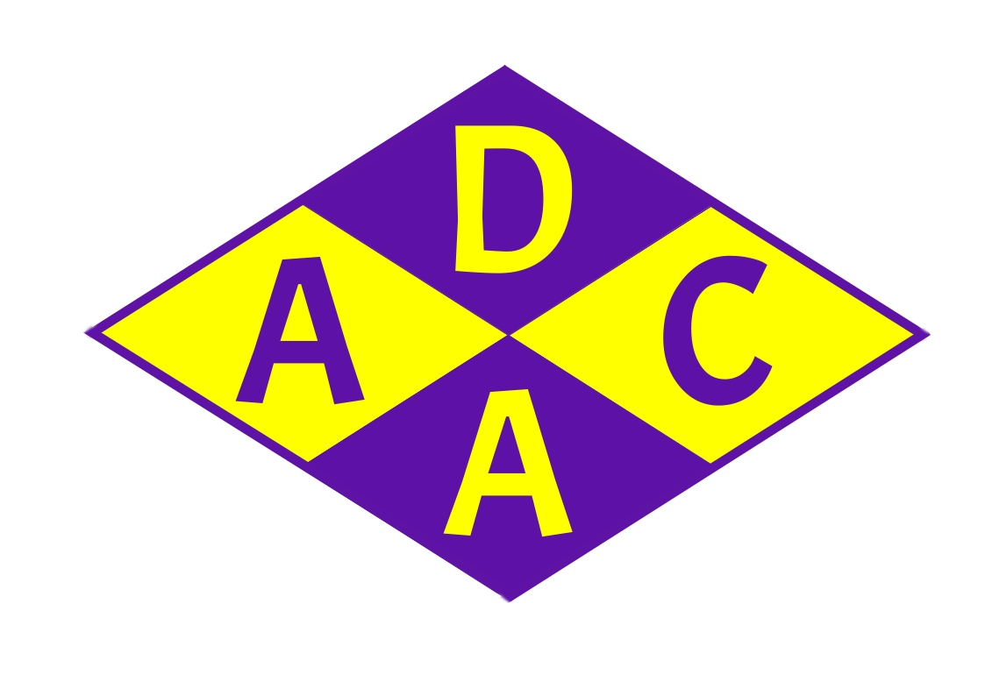
Dorset Arts & Crafts Association
Registered Charity No 306252

Application No (Office use only)

Application for DACA Grant 2026

Grant funding of up to £1,000 annually is available through the DACA Arts & Crafts Grant. The aim of the Grant is to support groups or individuals in the development of arts and crafts projects. This can include, but is not restricted to, personal study, group or community projects and support for those in education
Eligible groups and individuals who meet the application criteria are invited to apply for grants up to £1000.
Applications must be received by 30th November 2025. Applications cannot be accepted after this date.
Before completing your application, please read the details on www.dorsetartsandcrafts.org/grant to ensure that you are eligible to apply and that your proposal meets the award criteria.
Please send your completed application form

by email to Pauline Forsdyke, DACA Grant Officer, grant@dorsetartsandcrafts.org
or by post to Jenny Gurden, DACA Chair, 14 Leeson Road, Bournemouth, BH7 7AY

Section 1: About you

First Name |  |  | Last Name
Address
 |  |  |  |  | Post Code
Email |  |  |  |  | Phone
If your application is on behalf of a group, school or other organisation
Group Name
Group Type | Select from list.
Group email | If different from above |  |  |  | Group Phone | If different from above
Tell us a little about yourself or your group
Enter details here

Section 2: About your application
2.1 Your proposal
Your proposal must have a clear arts and crafts focus.

Additionally, your proposal must meet at least one of the following criteria. Please indicate which criteria you meet. You may select more than one.
☐ | Promoting the study and encouraging the education of the residents of Dorset
☐ | Supporting young people
☐ | Supporting those with additional needs
☐ | Supporting mental health and wellbeing
☐ | Community-based project
☐ | Developing new skills which can be used to further any of the criteria above
2.2 Details of your proposal.
Tell us what you want to achieve and how you will know whether you have met your goals.
Enter details here

2.3 Total amount Requested
How is this amount calculated? Please list your detailed costs below or provide the information on a separate spreadsheet if you prefer.
Enter details here
2.4 Timescales and milestones
If your application is successful, we will ask you for regular progress reports against your timescales or other milestones. Please provide us with as much information as you can about your planned timescale.
Project start date | Enter a date
Expected completion date | Enter a date
Please provide us with any other relevant information about your timescale and milestones
Enter details here

2.5 Your Showcase 2026 display
If your application is successful, we will ask you to contribute a display of work to our annual Showcase event at Purbeck School, Wareham. This display may consist of finished articles or work in progress, depending on the nature of your project. DACA may be able to supply some help with display equipment.

To aid your planning, Showcase 2026 dates are 31st July – 4th August. Your display must be set up on Wednesday 29th or Thursday 30th July and taken down on Wednesday 5th August.
Please indicate what form your display would take. We will discuss the detail of the display if your application is successful.
Enter details here

Section 3: Submitting your application
Please confirm the following before submitting your application
☐ | I have read and agree to the Terms and Conditions
☐ | I am authorised to make this application (if applying for a group or other organisation)
Date |  | Select date | Signature | Sign here  (an electronic or typed signature is acceptable)

